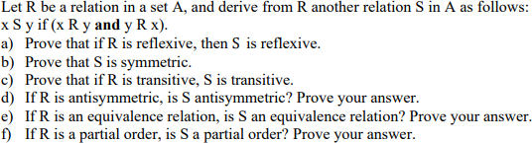**Q1**

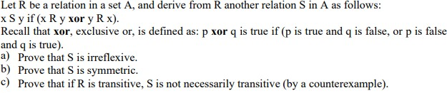**Q2**

**Q3.**

Assignment

(Part of Final Examination) Marks:10

